- In the billing page – There should be an option to mark payment collected – exactly similar to the one existing while creating a bill in walk-in registration. For example: If a user want to generate bill through the billing page – he clicks on “Generate Bill” button and in that page – along with everything there should be an option to mark payment collected. The bill should not always move to “pending” when a user is generating it. And it should be updated across all related fields and dashboard
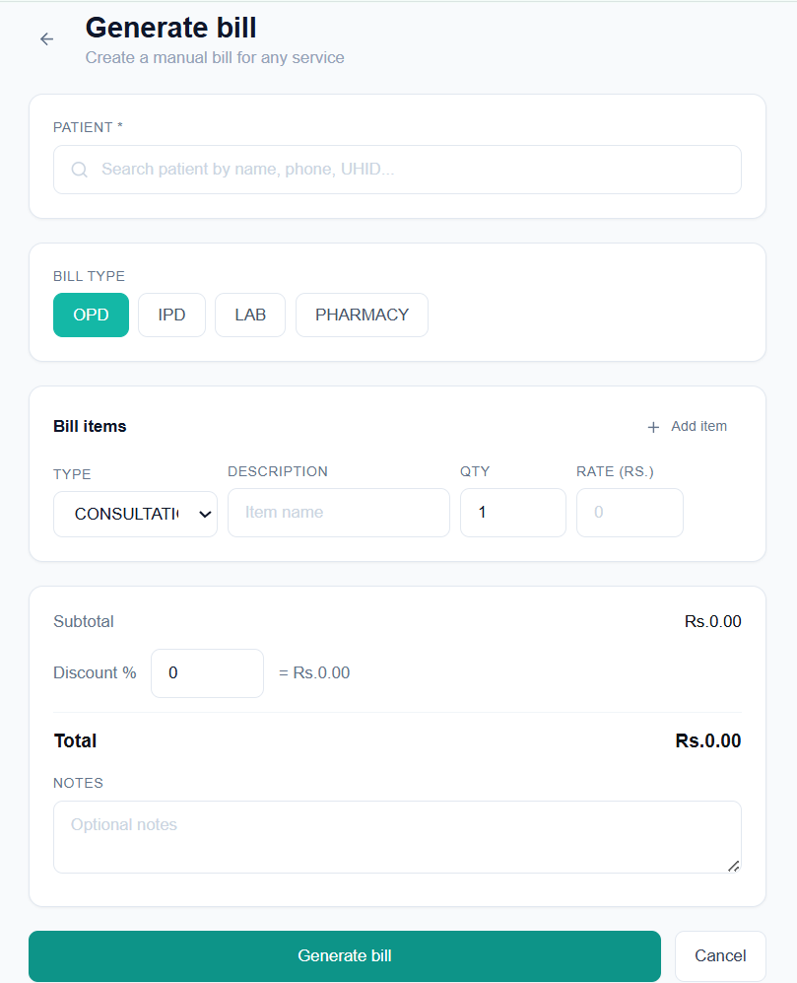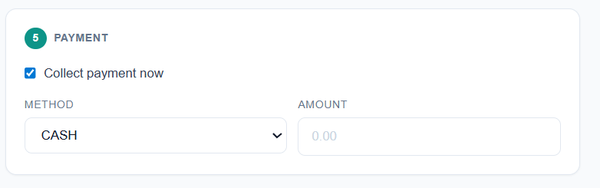
- When Clicking on collect for pending bills from the billing window – the system redirects me to patient’s profile – which is not correct. It should redirect me to bills tab of the patient’s profile
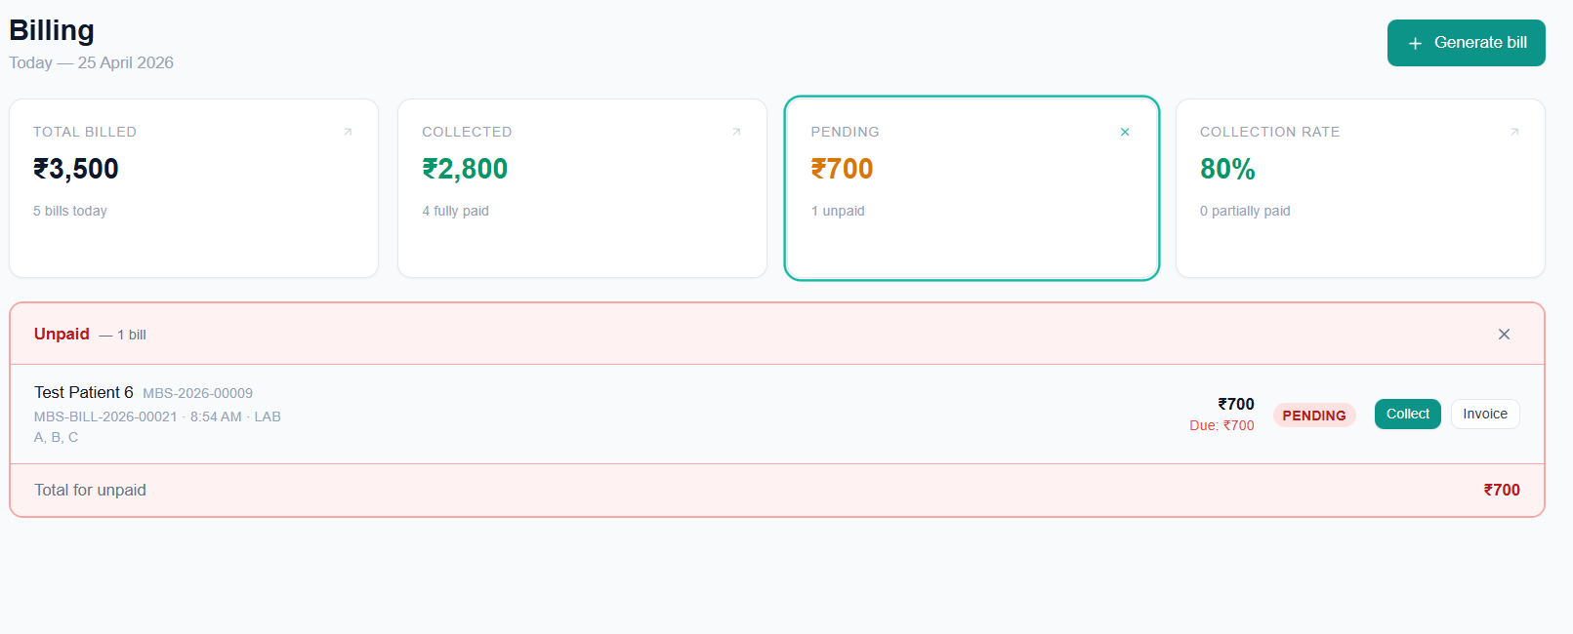
Landed on - 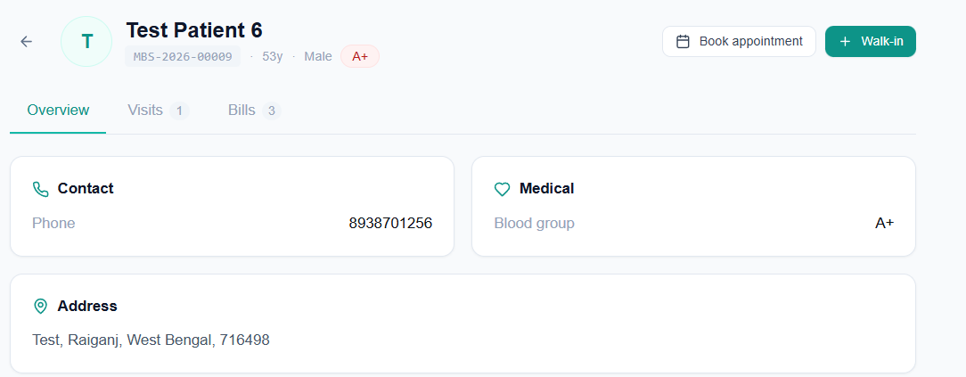
- Billing window should also have a calendar option to see bills for any particular date and a particular date range as well
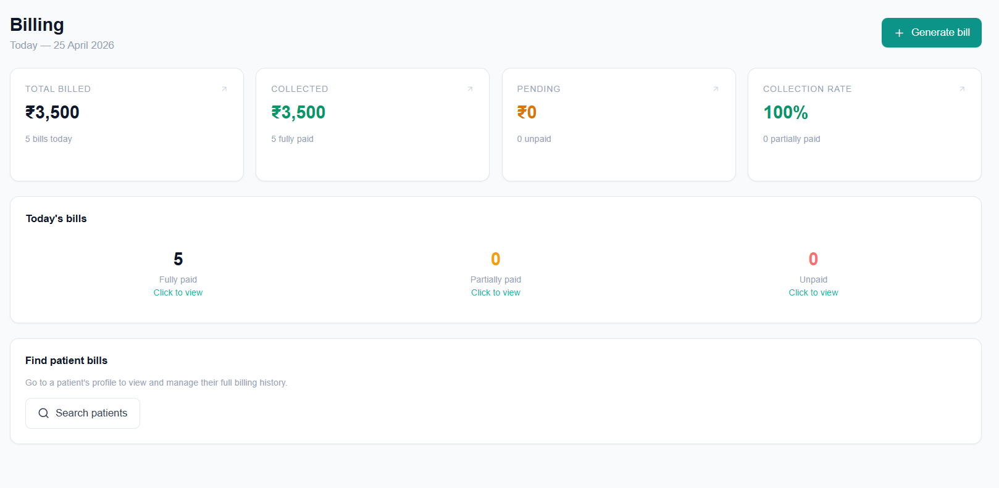
- Appointments window calendar for selecting a date or date range – not working – landing page shows this:
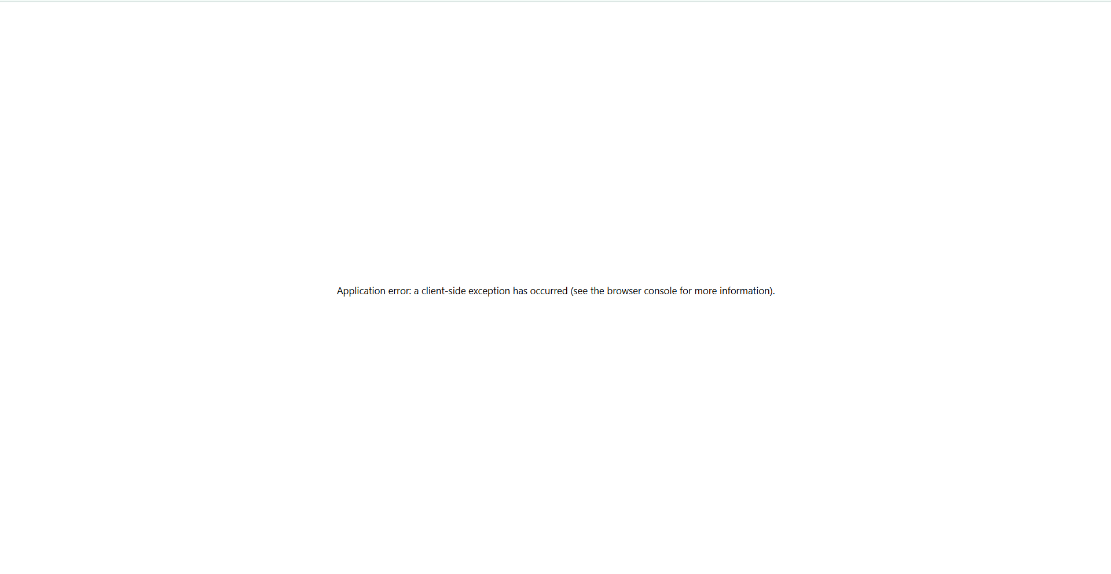

- From the bills tab of patient profile window along with print invoice there should be an option to send it via whatsapp as well
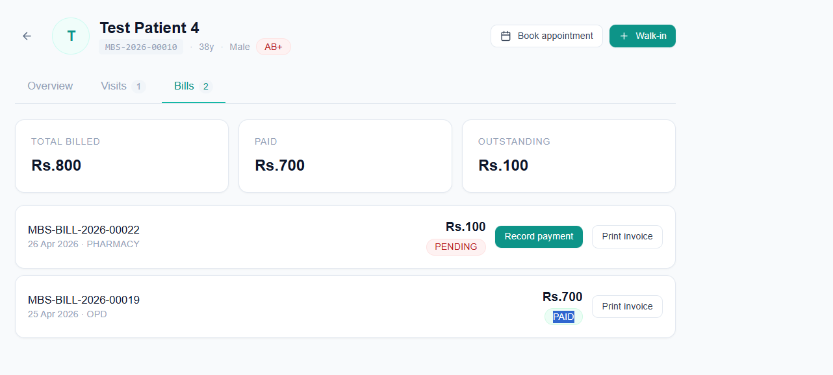
- From a patient’s profile – If I click on “Book Appointment” – the patient name should get auto-filled just like it happens when we click “Walk-In”
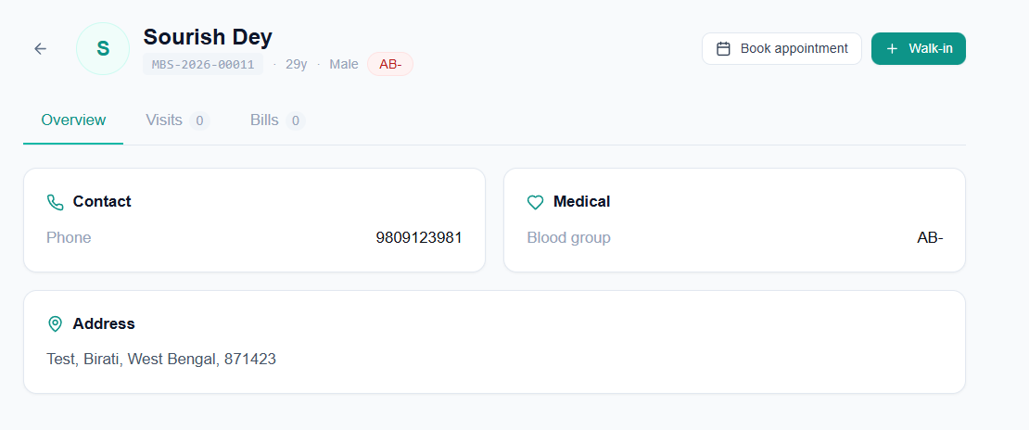
- There should be a “send on whatsapp” option in this print invoice page
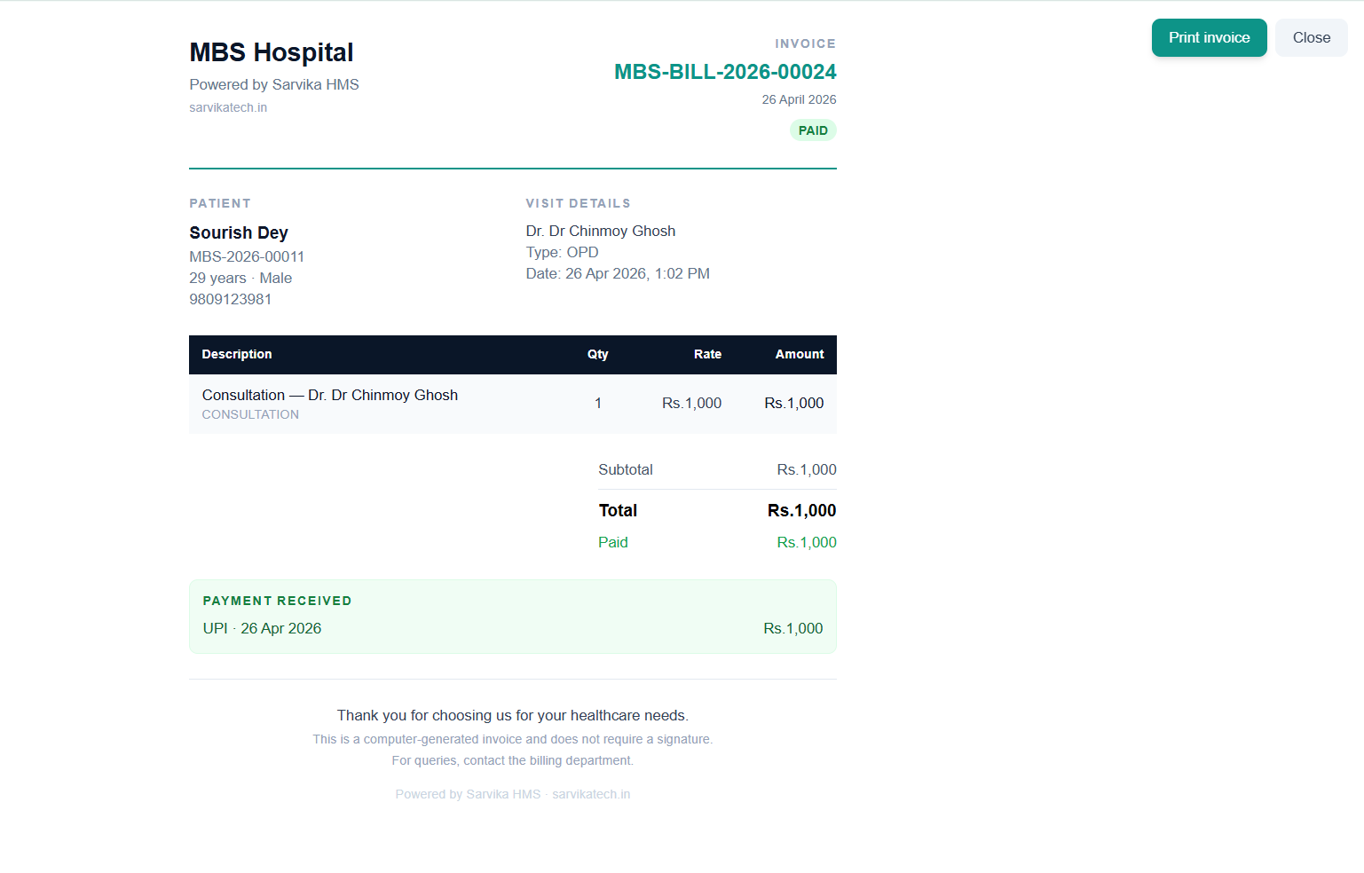

- With doctor number shows “0” even with a patient in there
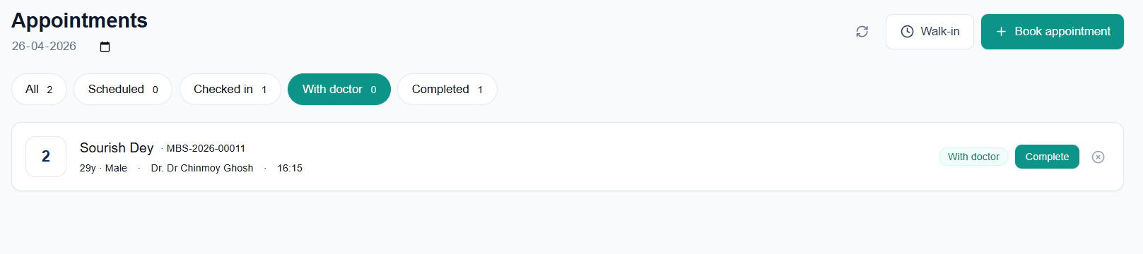
- IMPORTANT – we need a placeholder to upload prescription in the OPD file against each consultation. It might happen that the doctor did not do it digitally through “Start Consulation” button rather wrote a prescription on paper. So – there should be an option to upload prescription and complete consultation as well in the OPD page.

